**-**

1. **Introduction**

For Growth-Kinetic test, 3 systems will be used: 500ml CelcradleTM (Vaccicell) (section 4.1), and 150mm Flask (section 4.2), 24 well plates ().

Time of testing: 3h, 24h, 48h, 72h and 96h post seeding.

Parameters of monitoring: Cell Counting-by CVD (only for CelCcradle), Cell counting using trypan-blue for cells in the flask, PrestoBlueTM, Hoechst, PI, pH, Glucose, Lactate.l

1. **Related Documents**
   1. Start here
2. **Materials**

**3.1** 500ml CelcradleTM (Vaccicell)

**3.2** 150mm Flask (Corning)

**3.3** 24 well plate ()

**3.4** CVD ()

**3.5** Trypan blue

**3.6** PrestoBlueTM  X1

**3.7** Hoechst X1

**3.8** PI

**3.9** Complete Media

1. **Procedures**

For the day of CelCradle seeding, prepare **4-5** 150mm flask (~100milion cells/plate)

* Leave the remaining cells for the Flask seeding – Section 4.2.
* Leave10 clean carriers in 15ml empty tube.
  1. Day 0- CC seeding

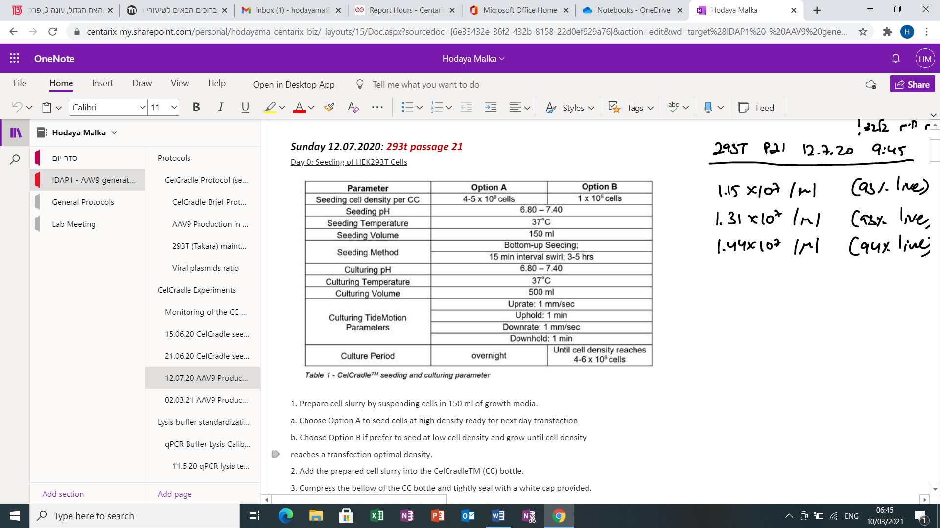

24h, 48h, 72h and 96h post seeding

* + 1. Prepare cell slurry by suspending cells in 350 ml of growth media (DMEM 10%).

(Fill in all parameters: Cell line, Growth media, passage, seeded hour - in the Excel file: “Growth-Kinetic Test Monitoring per day”)

* + 1. For the cells counting use the “Counting cells using the countess II WI-E-005” protocol. Add the results to the Excel file “Growth-Kinetic Test Monitoring per day”.
    2. Choose Option B if prefer to seed at low cell density and grow until cell density reaches a transfection optimal density.
    3. Add the prepared cell slurry into the CelCradleTM (CC) bottle.
    4. Place on the CelCradleTM stage with the parameter shown in Table 1 and incubate at 37°C for 3 – 5 hours for the cell to attach to the carriers. Ensure that all carriers are submerged in the cell slurry.
    5. Gently swirl the CC bottle every 30 minutes to allow cells that have not yet attached onto carriers to mix homogenously across the solution to promote homogenous seeding.
  1. Seeding in 150mm Flask and 24 well plate (#of flasks/Plates according to #of monitoring days):

Prepare cell slurry by suspending cells in total 24 ml of growth media (DMEM 10%) per flask. Prepare cell slurry by suspending cells in total 800ul of growth media per well (Fill in all parameters: Cell line, Growth media, passage, seeded hour - in the Excel file: “Growth-Kinetic Test Monitoring per day”)

* + 1. For the cells counting use the “Counting cells using the countess II WI-E-005” protocol. Add the results in the Excel file: “Growth-Kinetic Test Monitoring per day”
    2. Move gently the flask for better cell scattering and incubate at 37°C for 3 – 5 hours for the cell to attach to the flask surface.

|  |  |  |  |
| --- | --- | --- | --- |
|  | CelCradle x1 | Flasks x4 | 24 well Plates x4 |
|  |  | Day 4  Day 3  Day 2  Day 1  Day 0 | Day 4  Day 3  Day 2  Day 1 |
| Tests: | CDV, PrestoBlue, Hoechst, PI, pH, Glucose, Lactate  And cell count from media only at 3h | pH, Glucose, Lactate*,* Cell Counting using Trypan Blue | PrestoBlue, Hoechst, PI, Extra*-blank* |
| When: | 3h, 24h, 48h, 72h and 96h post seeding | 3h, 24h, 48h, 72h and 96h post seeding | 24h, 48h, 72h and 96h post seeding |

* 1. 3h. post seeding:
     1. 3 hours post the seeding process, gently mix the CC bottle to suspend any unattached cells.
     2. Sample the Carriers for **CVD cell** **count** and determine attachment efficiency (for CC) (Appendix D).
     3. Add all results to the attached Excel file (name: “Growth-Kinetic Test Monitoring per day”).
     4. Perform monitoring for the **pH**, **Lactate** and the **glucose** level: (Appendix A)
        1. Take 5ul media from the CelCradle and measure the glucose and the Lactate levels.
        2. Take 3ml media from the CelCradle, transfer to 15 ml tube.
        3. Do the same for the media in the flask.
        4. Measure the pH, glucose and Lactate in each tube.
     5. 10ul media (from CC and Flask): **Cell attachment** efficiency by **TrypanBlue** (refer to protocol in Appendix B)
     6. Add the results to the excel file (name: “Growth-Kinetic Test Monitoring per day”).
     7. For CelCradle: Upon reaching 80% attachment efficiency, top up the volume to 500 ml with growth media (DMEM 10%). Add time of adding the rest media to the excel file (name: “Growth-Kinetic Test Monitoring per day”).
  2. 24h., 48h., 72h., and 96h. post seeding:
  3. Sample the media for cell count and determine attachment efficiency (for Flask and CC), fill in all parameters mention in Excel File: “Growth-Kinetic Test Monitoring per day”.: The following are common parameters data that will be monitored daily:
     1. 3ml media (from CC and Flask): **pH,** **glucose** and **Lactate** measurement. (refer to protocol in Appendix A)
     2. 10ul media (from CC and Flask): Cell attachment efficiency by **TrypanBlue** (refer to protocol in Appendix B)
     3. 1X 150mm Flask: Viability by Cell Counting using **trypsin+ Trypan-Blue**  (refer to protocol in Appendix C)
     4. 2x3 carriers in 3 eppendorf : metabolic activity using **CVD** (refer to protocol in Appendix D)
     5. 3 carriers, 3 wells: metabolic activity using **PrestoBlue** (refer to protocol in Appendix E)
     6. 3 carriers, 3 wells: live/dead cell staining using **PI** & **Hoechst** stains (refer to staining protocol in Appendix F)

1. **Appendixes**
   1. Monitoring of CC bottle will be done daily, and the results will be documented at the attached excel file “Growth-Kinetic Test Monitoring per day”.
      1. Appendix A – Perform monitoring for the **pH**, **Lactate** and the **glucose** level:
         1. Take 5ul media from the CelCradle/Flask and measure the glucose and the Lactate levels.
         2. Take 3ml media from the CelCradle/Flask, transfer to 15 ml tube and measure the pH in each tube.
      2. Add the results to the excel file (name: “Growth-Kinetic Test Monitoring per day”).
   2. Appendix B: Protocol for Attachment efficiency of Media (by TrypanBlue)
      1. For CC or Flask:
         1. Mix 10ul of TrypanBlue and 10ul of the Media (CC or Flask) and transfer to the hemocytometer slide.
         2. Count cell pellet on hemocytometer.
         3. Add the results to the excel file Growth-Kinetic Test Monitoring per day.
   3. Appendix C: Protocol for small scale cell harvesting from carriers using **trypsin+ Trypan-Blue:**
      1. For Flask system:
         1. Harvest cells from flask: wash media out and add 3ml Trypsin
         2. Incubate for 1 min at 37oC
         3. Add 9ml media, harvest the cells and transfer it to 15ml tube.
         4. Mix 10ul of suspension cells and 10ul of TrypanBlue, and transfer to the hemocytometer slide.
         5. Count cell pellet on hemocytometer.
         6. Add the results to the excel file Growth-Kinetic Test Monitoring per day.
   4. Appendix D – Counting cells with **Crystal Violet Nucleus Dye Kit**:
      1. For CelCradle:
         1. Randomly pick 6 carriers and place in a petri dish.
         2. Add 2 carriers in a vial.
         3. Add 1ml of CVD reagent into each vial.
         4. Vortex each vial for 60 seconds.
         5. Place the vials in the incubator at 37°C for 1hr, vortex several times during incubation.
         6. Dilute samples with PBS to a countable range.
         7. Vortex.
         8. Take 10ul diluted CVD solution into cell counter.
         9. Count the cells using microscope.
         10. Add the results to the excel file Growth-Kinetic Test Monitoring per day.
   5. Appendix E – Protocol for performing **PrestoBlue** assay
      1. For CelCradle:
         1. Prepare 1x PrestoBlue solution in complete media
         2. Aliquot 500 ul 1x PrestoBlue solution in a 24-well plate
         3. Place 3 carriers, one at each well
         4. Incubate at 37˚C for 1 hour
         5. Transfer 200 ul of solution into a 96-well Plate
         6. Read at OD570 nm/OD600 nm
         7. Blank using reaction performed with empty clean carrier
         8. Add the results to the excel file Growth-Kinetic Test Monitoring per day.
      2. For 24 well plate:
         1. Remove the culture medium from 3 cell wells.
         2. Aliquot 500 ul 1x PrestoBlue solution on cells in 24-well plate
         3. Incubate at 37˚C for 1 hour
         4. Transfer 200 ul of solution into a 96-well Plate
         5. Read at OD570 nm/OD600 nm
         6. Blank using reaction performed with empty clean carrier
         7. Add the results to the excel file Growth-Kinetic Test Monitoring per day.
      3. PrestoBlue monitoring- by SYNERGY plate reader:
         1. Open the plate reader and computer, and enter the ____ software.
         2. Chose _____ for OD570 nm/OD600 nm read and start reading.
         3. Save results and take results by disk-on-key. Add results for the excel file Growth-Kinetic Test Monitoring per day).
   6. Appendix F – Protocol for carrier **Hoechst, PI** staining
      1. For CellCradle:
      2. Randomly pick 3 carriers into a 24 well plate; 1 carrier per well
      3. Add in 1ml of media containing 1 µg/ml PI, 1x Hoechst stains
      4. Incubate at 37˚C for a minimum of 30 minutes
      5. Add in 1 µg/ml PI into well; incubate 5 min;
      6. Image**.**
      7. Add the results to the excel file Growth-Kinetic Test Monitoring per day).
      8. For 24-well plate :
         1. Remove the culture medium from 3 cell wells.
         2. Add in 1ml of media containing 1 µg/ml PI, 1x Hoechst stains
         3. Incubate at 37˚C for a minimum of 30 minutes
         4. Add in 1 µg/ml PI into well; incubate 5 min;
         5. Image**.**
         6. Add the results to the excel file Growth-Kinetic Test Monitoring per day).
      9. Image the Hoechst and PI- by Microscope:
         1. Open the computer, the microscope, the camera and the light.
         2. Open the NIS software and chose “noam1” program.
         3. Put the 24 well plate on the mic. Stage and direct the zoom in order to see the cells.
         4. Put green light for RFP (PI) images, and purple light for DAPI (Hoechst) images.
         5. Save images and take results by disk-on-key. Add results for the excel file Growth-Kinetic Test Monitoring per day).
2. Reagents Preparation
   1. PrestoBlue 1x
      1. Calculate total ul needed for 500ul per well (#num. of wells +1 * 500ul).
      2. Mix 10x PrestoBlue (from stock) and complete media in ratio of 1:10. (see excel file Growth-Kinetic Test Monitoring per day: Reagent preparation).
   2. Hoechst [1ug/ml]
      1. Mix Hoechst[20mM] with PBS in ratio of 1:9, according to #num of experiments times (ex.: for 5 times take 5ulHoechst+40ul PBS).
      2. 1ug/ml Hoechst &PI:
         1. Calculate total ul needed for 1ml per well (#num. of wells +1 * 1ml).
         2. Mix Hoechst, PI and complete media in ratio of 1:1:1000 (ex.: for 9 wells take 9ul Hoechst, 9ul PI and 8,982ul complete media).

**For Gluc-Lac-pH monitoring:**

Seeding on 10cm2 plates:

|  |  |
| --- | --- |
| 10cm2 Plates – Media as Original | 10cm2 Plates – New Media each day |
| 4.31E+5  cells  Day 11  4.31E+5  cells  Day 10  4.31E+5  cells  Day 9  4.31E+5  cells  Day 8  4.31E+5  cells  Day 7  4.31E+5  cells  Day 4  4.31E+5  cells  Day 3  4.31E+5  cells  Day 2  4.31E+5  cells  Day 1  4.31E+5  cells  Day 0 | 4.31E+5  cells  Day 11  4.31E+5  cells  Day 10  4.31E+5  cells  Day 9  4.31E+5  cells  Day 8  4.31E+5  cells  Day 7  4.31E+5  cells  Day 4  4.31E+5  cells  Day 3  4.31E+5  cells  Day 2  4.31E+5  cells  Day 1  4.31E+5  cells  Day 0 |